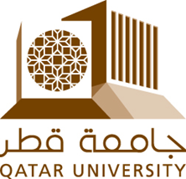

Economic Diversification in Qatar: Challenges & Opportunities
Ali Mohamed
201608099
Qatar University
BIOL 507 – L01
April 26, 2022
Dr. Jon Truby

Contents
Introduction: 2
Background: Status of Qatar and the GCC 2
Qatar’s Policies and Laws regarding diversification under QNV 2030 and QNDS 5
Qatar Policies regarding diversification under INDC and QNDC 9
Policy Recommendations: 11
Conclusion: 17
References: 18

Introduction:
The State of Qatar along with other GCC countries are facing a looming economic and climate crisis in the future due to their heavy reliance on the hydrocarbon industry. As oil prices decline and climate change approaches, many GCC countries including Qatar must be prepared to reduce their emissions and switch to industries that are not dependent on their limited hydrocarbon reserves. It is therefore necessary to investigate the policies, laws and strategies of the nation that need improvement so that economic diversification measures can be successful in the long run. This paper will look at the current measures put forward by the State of Qatar and assess the effectiveness of said measures towards economic diversification. Finally, recommendations will be given on areas that need improvement.

Background: Status of Qatar and the GCC
Qatar and its fellow GCC countries (Bahrain, Kuwait, Saudi Arabia, Oman, UAE) are known as rentier states; countries that derive their main income from an abundant resource, which is oil in this case. As Matsunaga (2000), puts it, rentier states are characterized by two unique features: maintaining political autonomy by removing tax on the citizens and the removal of any aspirations of democracy from its citizens due to its generous redistribution policy of revenues in the form of free water, electricity, and food. This form of governance tends to suffer from a variety of factors. An economy solely based on one resource is highly volatile, as fluctuating prices of the resource such as oil would bring sudden fluctuations in the economy. Rentier states also suffer from an unproductive national workforce while having slow growth in the private sector due to the fiscal policies laid out by the government favoring public sector jobs (Matsunaga, 2000).
As it stands, the GCC states are currently home to 30% of the world’s oil reserves (largest share) and 21% of the world’s gas reserves (second largest share) (Sim, 2020). The State of Qatar by itself has one of the largest natural gas reserves in the world (Esen & Oral, 2016). Hydrocarbon exports account for over 80% of the exports for majority of the GCC countries except UAE who have seen a relative amount of success in diversification measures, and Bahrain who have depleted most of their reserves. Moreover, the non-hydrocarbon industries such as construction and infrastructure are supported by the hydrocarbon revenues, which makes diversification from oil and gas difficult (Figures 1-3). Such heavy reliance on a diminishing resource will have compounding consequences in the future (Kabbani & Ben, 2021).
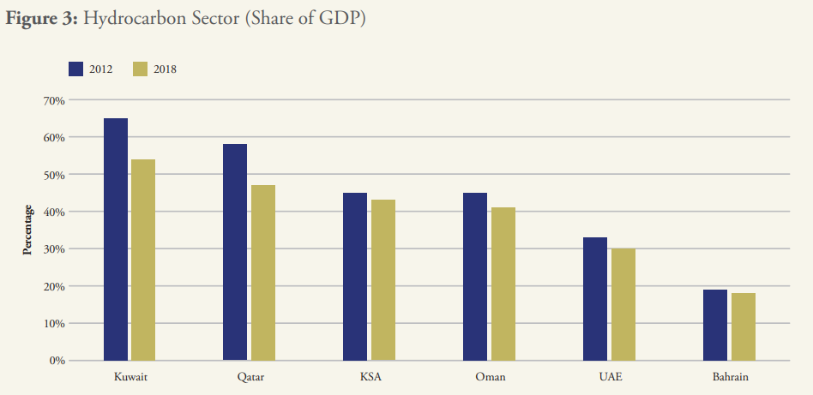
Figure 1: Percentage Share of GDP by Hydrocarbon Sector (Kabbani & Ben, 2021).
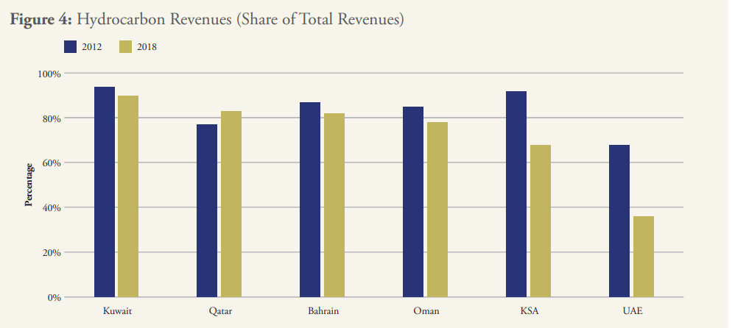
Figure 2: Percentage Share of Hydrocarbon Revenues from Total Revenues (Kabbani & Ben, 2021).
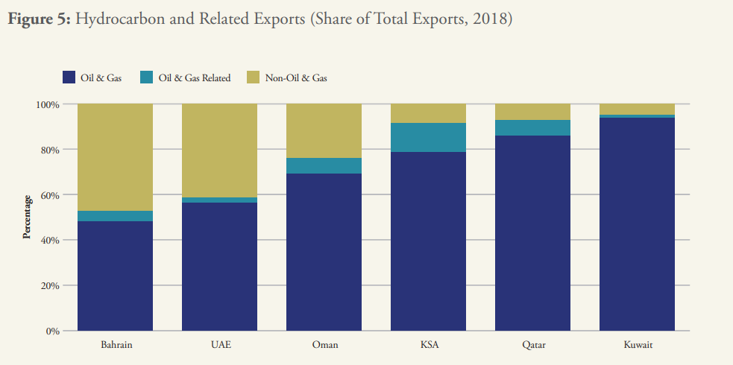
Figure 3: Percentage Share of Hydrocarbon and Related Exports from Total Exports in 2018 (Kabbani & Ben, 2021).

Additionally, the GCC countries along with Iran and Iraq contribute to 6% of global CO2 emissions, making climate change a significant issue for the region. The physical effects of climate change such as rising sea levels and temperatures are alarming as they could render the region unhabitable and climate adaptation would be a costly venture. Adding to this, declines in oil revenue are expected to happen by 2040 if not sooner as competing markets emerge from the renewables sector and efficient battery storage systems are developed as countries shift to lower carbon emission policies (Krane, 2020). These declines are also a threat to the political structure as it revolves around sharing revenues with its citizens. An unsustainable economic structure, decline in oil demand and the threat of climate change are clear indications that economic diversification is no longer a preferable policy, but an absolute necessity for Qatar and its neighbors. The GCC states have realized this and have therefore integrated diversification as part of their national plans, although the effectiveness of these plans remains to be answered.
Economic diversification, according to Hvidt (2013), is a broad societal process that transforms a country from a single source of income (oil and gas) to one in which numerous sources of income are generated throughout the primary, secondary, and tertiary sectors, and where vast segments of the population, including public and private firms, engage in the development process. According to Mishrif (2018), Diversification is a difficult and time-consuming process that necessitates significant structural changes in the economy. It can happen within the same industry, such as energy, by transferring resources and investment from upstream to downstream businesses in oil and gas, or by opening new markets for non-fossil fuel products like renewable energy. The next section will look at the policies and laws in Qatar regarding economic diversification.

Qatar’s Policies and Laws regarding diversification under QNV 2030 and QNDS
In 2008, Qatar released its national Vision 2030, which was followed by the Qatar National Development Strategy 1 2011–2016 (QNDS-1) and Qatar National Development Strategy 2 2018–2022 (QNDS-2), which defined the expenditure and implementation of the economic plans. The goal of QNV is to transform Qatar into a developed country by 2030, capable of supporting its own development and providing a high level of life for future generations. It also aspires to develop a knowledge economy that will position the country as a regional center for high-value industrial and economic operations. Economic diversification is one of its primary strategies for attaining this goal, which includes supporting private businesses, encouraging entrepreneurship, developing world class education and infrastructure, enhancing the business climate, restructuring the labor market, and bolstering regional integration (Government Communications Office, 2022).
The QNDS-2 is the latest strategy framework, updating the nation on the outcomes of QNDS-1 and setting targets for the years 2018-2022. The document acknowledges that investing in foreign assets is a short-term plan that is subject to high risk due to fluctuations in financial markets. The QNDS-2 like its predecessor, combines diversification and private sector development under the Economic Diversification and Private Sector Development (EDPSD) strategy. The strategy primarily focuses on two areas: productivity and growth led by the private sector in addition to selecting six priority economic areas for the development of the national economy, as shown in EDPSD framework (Figure 5) (Hukoomi. n.d.).
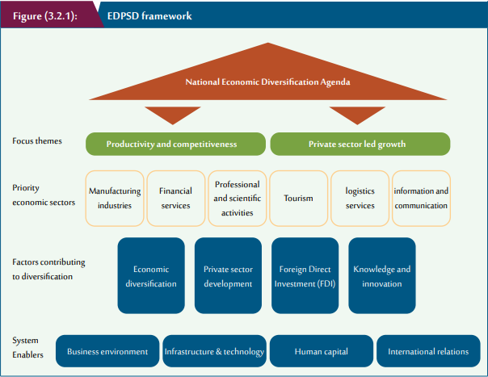
Figure 4: EDPSD Framework (Hukoomi. n.d.)
Progress towards the EDPSD showed an increase in diversification from 2012 – 2016. However, this progress would be halted as the enablers of the non-hydrocarbon sector are expected to slow down during the years 2018-2022 while public expenditure will be managed more efficiently. The following polices and laws were put into effect to help promote diversification and growth of private sector:
- Public Private Partnership (PPP) law was established in the year 2020 to support knowledge-based business sector. Several PPP-based initiatives in the education, health, and tourist sectors have also been launched (Dimitropoulos & Ezenagu, 2021).
- Qatar established various major initiatives for food security, logistics, storage, and tourism to promote the private sector and strengthen its role in economic development. The MEC supervises the implementation of these programs in collaboration with government organizations in order to open new investment sectors and chances for the private sector to be motivated and engaged (Hukoomi. n.d.).
- In order to meet the competition goal, the MEC created a new Competition Law and presented it for review and approval to higher authorities. The MEC also conducted many evaluations on the competitive position in several critical economic sectors, including cars, food, basic materials, and brokerage, as well as the start of liberalization in a few of them. The Protection of Competition and Prevention of Monopolistic Practices Committee and the Pricing and Profit Setting Committee were both established by the MEC (Hukoomi. n.d.).
- Qatar has taken a number of steps in order to attract more foreign direct investment. Businesses establishing operations in Qatar benefit from a competitive legal system based on English common law, the ability to trade in any currency, 100 percent foreign ownership, 100 percent profit repatriation, and a ten percent corporate tax on earnings generated locally. Implementation of a liberal economic policy to facilitate business and investment, as well as providing special benefits to non-Qatari foreign investors, such as enabling them to give up to 100% of the capital for any project and exempting them from paying income tax for up to ten years (Government Communications Office, 2020).
- A variety of measures aimed at promoting and enhancing the business climate were completed, including the issuance of a new Commercial Companies Law; the completion of the process of updating, streamlining, and changing 51 procedures and steps of business establishment into online and mobile services; and the elimination of the QAR 200,000 minimum capital requirement (Hukoomi. n.d.).
- The MEC established the Economic Zones Company (Manateq) to oversee the special economic zones in Qatar, with the goal of improving land use to support the national economy and competitiveness. The first two economic zones, with a total area of 4 and 34 square kilometers, were established at Abu Fintas and Umm al-Houl in 2015. The third zone, Karaana, was opened in 2018. A draft Economic Zones law that will regulate these zones has been approved by the Council of Ministers and the Shura Council (IMF, 2019).
- Several policies have also been put into place that enable people with startup ideas to apply for funding such as QDB’s accelerator program. These programs help talented minds link up with possible investors to bring forth new ideas to fruition (Pradhananga et al., 2017).
- Education policies have brought in new universities including the prominent Education City that is to serve as a knowledge hub for the nation. Education City is a collection of highly recognized universities worldwide that seek to foster a transfer of knowledge that would enable Qatar to target different unique markets in areas of media, health, design, and tourism (Mishrif, 2018).

Qatar Policies regarding diversification under INDC and QNDC
Nationally Determined Contribution (NDC) is a document submitted by a nation to showcase the efforts put in place by the country in order to achieve the goals of tackling climate change under the Paris Agreement. Since Qatar is amongst the countries that have signed the agreement, they have submitted two NDCs, one in 2015 (INDC) and the latest one in 2021 (NDC). These documents have a section called Economic Diversification with Mitigation Co-benefits to highlight diversification measures in accordance with climate change.
In the NDC reports, Qatar has highlighted that the peninsula is particularly sensitive to sea level rise. Climate change would also have detrimental effects on the population, wildlife, tourism, and infrastructure of the country. The documents state that Qatar must diversify its economy to preserve a stable and vibrant economy. In accordance with decision 24/CP.18, Qatar intends to broaden its economic diversification away from hydrocarbons. The documents address different areas of improvement for economic diversification that are as follows:
- Energy efficiency and process optimization are the goals of many programs and projects around the country. The document states that Qatar is working to increase energy efficiency by utilizing available resources. In the Oil & Gas sector, processes will be optimized to be more efficient to reduce flaring and reducing GHG emissions in total. Energy efficiency measures such as district cooling and energy labeling for all electronic equipment are being implemented in a methodical way, and they are playing an increasingly important part in the national economic diversification strategy by reducing energy intensity and the need for energy subsidies, as well as reducing overall GHG emissions from families and small and medium businesses. In addition to the numerous energy conservation measures, Qatar has implemented several water conservation initiatives that will greatly reduce the sector's environmental footprint (UNFCC, n.d.).
- Despite its availability of gas, which is a cleaner source of energy compared to coal, Qatar is investing substantially in other natural resources to diversify its economy while having less emissions. Solar energy generation has been prioritized in the hopes of becoming a regional solar energy supplier. However, due to the harsh environment and weather conditions, utilizing such renewables as stable power sources is extremely difficult due to a lack of access to advanced technology, which is required to use these sources properly and efficiently. Nonetheless, several national entities have begun to examine solar and wind energy as a source of electricity for small structures, with the goal of expanding the market and increasing economic diversity (UNFCC, n.d.).
- Qatar has a strong commitment to research and development. In accordance with its National Research Strategy, Qatar has made significant investments in research and development in a variety of fields, including sustainable energy. Many research projects are underway in a variety of sectors, including enhancing the environment to adapt to the effects of climate change, harnessing clean energy and renewables, minimizing emissions to the atmosphere, and developing technology that turn emissions into valuable products (UNFCC, n.d.).
- Great strides have been made toward establishing a world-class education system with the goal of fostering an environmentally conscious society. Environmental studies, especially climate change, are a focus of universities and research institutes. Overall, Qatar's educational concentration is predicted to result in graduates with expertise in knowledge-based services, healthcare, and green technology (UNFCC, n.d.).
- Qatar has a long-term strategy for growing its tourist industry, which includes a set of well-defined goals, initiatives, and policies based on international best practices and established through a national consultation process. The goal of this plan is to lessen reliance on hydrocarbon resources by developing sustainable tourism techniques (UNFCC, n.d.).

Policy Recommendations:
While the tax incentives are attractive to foreign investors, setting up a business tends to be very hectic (a lot of paperwork) and there are a lot of restrictions on the freedom to do business. For example, every business in Qatar needs to have a physical address present, which affects e-commerce businesses (Kabbani & Ben, 2021). To solve these issues, policies need to include bankruptcy laws, eliminate physical address requirement, reduce the number of steps required to register a business, allocate a minimum share of government contracts to Small and Medium Sized Enterprises (SMEs), ensuring timely government payments, and improving SMEs' access to capital.
Many SoEs (State Owned Enterprises) were formed with the goal of boosting specific sectors of the economy, and they now dominate non-oil exports (Kabbani & Ben, 2021). Entry barriers may prohibit private enterprises from competing on an equal footing in sectors where large SoEs dominate. Reduced competitive barriers and integration of the private sector, could help diversification.
Building expertise in certain clusters of entrepreneurship and innovation should be the goal of policies. The grouping/clustering of non-hydrocarbon industries that provide similar services would significantly reduce costs and improve logistics of these industries. A well-coordinated investment strategy should enable systematic access to funding for priority industries, integrate new international ventures into the economy. Human capital investments should be focused on the specific skills required in priority industries. Expertise takes time to develop, and Singapore's example demonstrates the significance of setting clear, achievable goals while being ambitious in the long run.
Export markets and competition can be utilized intentionally to hold recipients of support accountable. In many countries, policies to promote specific industries have resulted in inefficient import substitution (IMF, 2019). Avoiding this consequence necessitates strictness and discipline: if no improvement is made, support should be stopped. The example of Korea shows us that success in export markets should be utilized as an external benchmark to gauge development in areas that are new to the Qatari economy but not to global markets. To guarantee that competition is maintained even in new sectors, policies should strive to encourage sectors rather than specific enterprises.
Several policies can help to improve citizens' incentives and capacity to work in the private sector. Jobs and earnings in the public sector must be strictly limited, and people should be informed that they should not expect readily available work in the public sector. Rather than relying on government employment as a safety net, unemployment insurance and job search assistance should be in place to ensure that those who are unemployed have a minimal income and the motivation to work. Vouchers could be utilized for various apprenticeships and education to encourage skill acquisition when needed, just as they are in Belgium and Germany (IMF, 2019). Additionally, quality of teachers and early childhood education improvements can help students achieve more and shift cultural views.
States in the Gulf Cooperation Council should work to separate politics and business. The Emirates, Saudi Arabia, and Bahrain all had imposed a boycott on Qatar. Supply lines, capital inflows, company contracts, and even staff living arrangements were all interrupted by the blockade (Kabbani & Ben, 2021). All countries participating paid a high price for it, with little political benefit to show for it. This has significantly weakened foreign interest in the region. GCC states should keep in mind the advantages of maintaining a consistent and reliable investment climate and strive to keep politics out of the way of the more important long-term goal of generating sustained economic development and preserving future generations' prosperity. Qatar needs to work with its GCC neighbors and open trade routes, removing trade restrictions and establishing a reliable and resilient network.
The reliance on limited gas reserves is problematic for the country and the onset of Climate Change makes it an absolute necessity in Qatar to switch to alternate sources of energy. While solar looks promising in the future, the challenges remain due to Qatar’s harsh dusty environment. For this reason, the country seems to be reluctant to switch to renewables especially with the huge amount of gas reserves remaining. Moreover, the efficiency of solar energy is a huge obstacle in the adoption of this renewable source. The Al-Siraj solar plant is the latest project, and it is only able to cover 10% of Qatar’s current power demands (Siraj Energy, n.d.). Current renewable energy resources also suffer from a hidden problem that advocates of renewable energy fail to mention, i.e., these energy systems cannot by themselves supply energy on their own even if they acquire efficiency to supply 100% of our energy. This is because they are dependent on the hydrocarbon sector to supplement them. For example, solar energy must be stored in batteries/grids as the sun is only available during the day. These storage systems such as lithium batteries are created by hydrocarbon industries (Flexer et al., 2018; Brook et al., 2014; Wanger 2011), essentially becoming the backbone of renewable energy sources so a future with clean energy production is questionable with this system. Additionally, we are running out of time to develop sustainable solar/wind energy systems as current efforts will reflect climate change scenarios soon. A viable source of clean energy that has unfortunately gained backlash due to a historic accident is nuclear energy. Nuclear energy was discovered decades ago and had it not been for the Chernobyl incident, it is very likely that it would have been integrated into every country’s energy system in the battle against climate change. First and foremost, nuclear plants emit less emissions than even solar technology (Figure 6) which is considered a renewable source. In the United States, a typical 1,000-megawatt nuclear power plant requires a little more than 1 square mile to run (USDOE, 2019). According to the National Energy Institute, wind farms demand 360 times more land area to produce the same amount of power and solar photovoltaic plants require 75 times more land area. It is also interesting to note that all the used nuclear fuel produced by the nuclear energy sector in the United States during the last 60 years would fit on a football field with a depth of less than 10 yards. This used up fuel can also be recycled and reprocessed. Moreover, nuclear energy is the most reliable source of energy, it requires the least maintenance while being able to produce maximum power more than 92% of the time during the year, which is twice as much as natural gas and coal and about three times more reliable than solar and wind (Figure 7). Nuclear technology is constantly being updated with time and small modular reactors SMRs will soon hit the market that can be utilized in areas that don’t have the land to house a nuclear plant (USDOE, 2019). Majority of the concerns with this source of energy have been addressed by improvements and innovation including safety and waste storage measures, making it the most resilient option capable of supporting the energy demands of Qatar, without facing any technical issues. The UAE has understood the significance of this resource and has finished the construction of the Al-Barakah nuclear power plant, capable of supplying 1/4th of the nation’s energy demand (Barakah Nuclear Energy Plant, n.d.). Like always, the UAE has always been ahead of the curve in terms of economic diversification and energy diversification. It is important that policy makers in Qatar look at the example of UAE and initiate plans to adopt a similar plant after doing a feasibility study. The step taken by UAE should make it easier for Qatar to make a case to its GCC neighbors in case they object to a nuclear powerplant construction. Qatar can easily invest in this source of energy due to its rich economy, making it feasible to employ the best nuclear technology out there. It also opens a world of possibilities, Qatar can decide either to keep it part of the mix of renewables, use solar and nuclear in a complimentary manner or create new industries such as hydrogen production from nuclear energy. Moreover, the energy intensive desalination plants would no longer be contributing as much to climate change. If proper networks between its GCC neighbors are made, Qatar could also potentially profit from supplying nuclear energy to the rest of the Gulf. Several studies have pointed out the viability of nuclear energy to solve climate change problems and energy needs (Sim, 2020; Sadekin et al., 2019; Brook et al., 2014). However, policy makers remain hesitant due to an event that happened decades ago. The compounding benefits of this technology can bolster economic diversification in a plethora of ways that will help Qatar stand out among its GCC states.
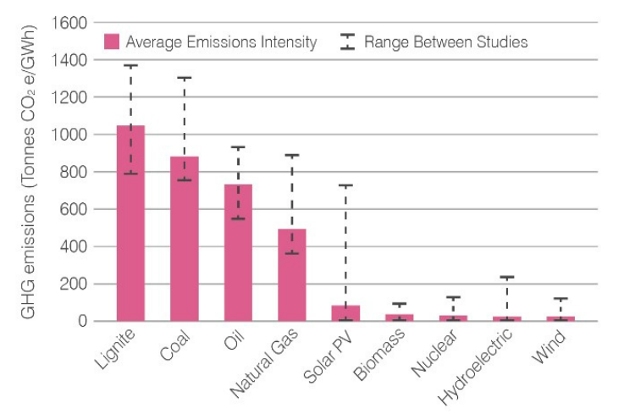
Figure 5: Emission levels from different energy sources (Sadekin et al., 2019)
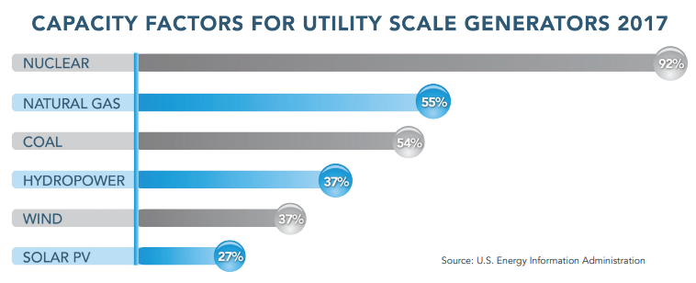
Figure 6: Capacity of different energy sources (USDOE, 2019)

Conclusion:
The State of Qatar has introduced several laws and policies to improve economic diversification in the long run. However, these measures do not seem to be adequate to reach true diversification. While the country acknowledges the impending threat of climate change, the reluctance to adopt strict measures in favor of the large gas reserves present is seen in the national vision and other policy reports. The State of Qatar needs to learn from countries such as Malaysia, Chile and Mexico who have successfully achieved economic diversification and employ similar strategies to improve the existing legal framework. Addressing the needs of the private sector and its independence from the public sector, creating a competitive economy and workforce, strengthening regional cooperation, and switching to a clean energy source are important areas to tackle, if diversification goals are to come true while mitigating the impacts of climate change.

References:
Barakah Nuclear Energy Plant. (n.d.). Retrieved April 26, 2022, from https://www.enec.gov.ae/barakah-plant/
Brook, B. W., Alonso, A., Meneley, D. A., Misak, J., Blees, T., & van Erp, J. B. (2014). Why nuclear energy is sustainable and has to be part of the energy mix. Sustainable Materials and Technologies, 1, 8-16.
Dimitropoulos, G., & Ezenagu, A. (2021). Qatar's new public-private partnership law: Towards a sustainable approach to development. Retrieved April 25, 2022, from https://www.hbku.edu.qa/en/news/sustainable-approach-development
Esen, V., & Oral, B. (2016). Natural gas reserve/production ratio in Russia, Iran, Qatar and Turkmenistan: A political and economic perspective. Energy Policy, 93, 101-109.
Flexer, V., Baspineiro, C. F., & Galli, C. I. (2018). Lithium recovery from brines: A vital raw material for green energies with a potential environmental impact in its mining and processing. Science of the Total Environment, 639, 1188-1204.
Government Communications Office. (2022, April 19). Qatar National Vision 2030. Retrieved April 25, 2022, from https://www.gco.gov.qa/en/about-qatar/national-vision2030/
Government Communications Office. (2020, January 31). Economic policy. Retrieved April 25, 2022, from https://www.gco.gov.qa/en/focus/economic-policy/
Hukoomi. (n.d.). Qatar second national development strategy 2018-2022. Retrieved April 25, 2022, from https://hukoomi.gov.qa/en/downloadable/qatar-second-national-development-strategy-2018-2022
Hvidt, M. (2013). “Economic diversification in Gulf Cooperation Council (GCC) countries: Past record and future trends. Kuwait programme on Development, Governance and Globalisation in the Gulf States, London School of Economics and Political Science, Issue, (27), 1-49.
International Monetary Fund. Middle East and Central Asia Dept. (IMF, 2019). Policies to Drive Diversification for Qatar. Qatar: Selected Issues, 2019(147).
Kabbani, N., & Ben Mimoune, N. (2021). Economic diversification in the Gulf: time to redouble efforts. Brookings Doha Center, Briefing Policy, January, Doha, Qatar.
Krane, J. (2020). Climate action versus inaction: balancing the costs for Gulf energy exporters. British Journal of Middle Eastern Studies, 47(1), 117-135.
Matsunaga, Y. (2000). L’État rentier est-il réfractaire à la démocratie?(Is the Rentier State Resistant to Democracy?). Critique internationale, 8, 46-58.
Mishrif, A. (2018). Introduction to economic diversification in the GCC region. In Economic Diversification in the Gulf Region, Volume I (pp. 1-26). Palgrave Macmillan, Singapore.
Pradhananga, R., Nawaz, W., Batur, I., & Koç, M. (2017). Industry-University-Government Partnership (IUGP)–trends, drivers and policy recommendations for Qatar. In ISPIM Innovation Symposium (pp. 1-14). The International Society for Professional Innovation Management (ISPIM).
Sadekin, S., Zaman, S., Mahfuz, M., & Sarkar, R. (2019). Nuclear power as foundation of a clean energy future: A review. Energy Procedia, 160, 513-518.
Sim, L. C. (2020). Low-carbon energy in the Gulf: Upending the rentier state?. Energy research & social science, 70, 101752.
Siraj Energy (n.d.). | Qatar Electricity & Water Co. Retrieved April 25, 2022, from https://www.qewc.com/qewc/en/portfolio-item/siraj-solar-energy/
UNFCC. (n.d.). Qatar NDC Report. Retrieved April 26, 2022, from https://www4.unfccc.int/sites/NDCStaging/Pages/All.aspx
USDOE Office of Nuclear Energy (2019). The ultimate fast facts guide to nuclear energy. Retrieved April 26, 2022, from https://www.osti.gov/biblio/1545613-ultimate-fast-facts-guide-nuclear-energy
Wanger, T. C. (2011). The Lithium future—resources, recycling, and the environment. Conservation Letters, 4(3), 202-206.

