

Office of the Vice President for Academic Affairs
Qatar University Academic Promotion

Verification Checklist of the College of Business and Economics
Professor / Research Professor

This checklist is a guideline to ensure that the promotion file meets the criteria specified in the promotion policy. QU Academic Promotion Policy and College Academic Promotion Guidelines remain the official and authoritative documents.

Applicant Name: …………………………….…….
Rank Applying for: …………………………….…….

No. | Item |  |  |  |  |  |  |  |  |  |  |  |  |  |  |  |  |  |  |  |  | Please tick (√)
No. |  |  |  |  |  |  |  |  |  |  |  |  |  |  |  |  |  |  |  |  |  | Yes |  |  |  | No
1 | Is the applicant a full-time faculty member?
2 | Has the applicant spent at least one (1) year at QU?
3 | Has the applicant been in the academic rank for at least five (5) years?
4 | Have the research papers submitted for promotion been published or accepted for publication after the applicant has obtained a doctorate (or its equivalent) and Associate Professor rank?
5 | For the Research track, has the applicant submitted double the papers’ requirements (in terms of number and quality)
6 | For applicants with less than 5 years but at least 4 years of experience at the current rank, has the applicant submitted double the papers’ requirements (in terms of number and quality)
7 | Is there a decision of a non-renewal of the contract of the faculty member?
8 | Was the overall annual performance of the applicant in the previous year: “Meet expectation”?
9 | Is Qatar University the only affiliation or (primary affiliation if published during the first 6 months after joining QU) in at least 50% of the publications?  “Double affiliation is accepted for promotion during the first six months after the applicant’s joining date to Qatar University, provided that Qatar University is presented as the first affiliation for the applicant”.
9 | Are there any publications with double affiliation that were published more than 6 months after the applicant’s appointment at QU or that mention QU NOT as the first affiliation?
10 | Is there any paper published before the previous promotion?  The publications submitted for promotion must not have been used in a previous promotion and must have been submitted for publication after the date of the meeting minutes of the university promotion committee in which it is indicated that the candidate’s promotion file has fulfilled the conditions for applying for promotion.
11 | There is no data extraction from PhD or MSc?
12 | If the applicant is reapplying for promotion,
12 | Did they wait for two (2) consecutive promotion cycles from the date of rejection letter?
12 | Did they make a substantial addition compared to the previous application with more than 50% of the submitted publications not used in the previous application?
12 | Did they receive a peer review score in teaching in the year immediately preceding the year of re-submission of at least 5.5 out of 7?
13 | Are the papers submitted for promotion published in at least three different journals?
14 | Has the applicant submitted more than one refereed review article, refereed book, or book chapter?  “The promotion request may include a book or a chapter of a book, and the publisher is at least indexed in Scopus”;
15 | Has the applicant submitted at least seven (7) peer-reviewed publications?
16 | Has the applicant submitted more than 2 accepted papers for publication?  The number of accepted publications should not exceed two (2)
17 | Is the applicant a senior or sole author in at least 4 papers?  The number of publications in which the applicant is a senior or sole author should be at least four (4)  The applicant's name appears in the publication either first or immediately following the name of a junior co-author(s) (such as a student, research assistant, or postdoc).
18 | Is the total number of points for the 7 publications not less than (15) points  “The applicant MUST indicate the five publications to be used for computing the total points”
19 | Is the total number of points for the publications in which the applicant is a senior or sole author not less than five (7) points?  “The applicant MUST indicate the five publications to be used for computing the total points”
20 | Has the applicant filled out the table** and provided appropriate evidence of the impact factor according to Web of Science, as well as the classification in Scopus or Web of Science?
Publications
21 |  | 1 |  | 2 |  | 3 |  | 4 |  | 5 |  | 6 |  | 7 |  | 8 |  | 9 |  | 10 |  | 11 |  | 12 |  | 13 | 14
21 | Paper published or accepted for publication, after the date of obtaining Associate Professor rank while holding a PhD degree
21 | Peer-Reviewed  Original research article (ORA)
21 | Peer-Reviewed  Book/ Book chapter/  review article / Patent  (Max 1)
21 | Quality of the journal Level points**
21 | Listed in SCOPUS or ISI Web of Science
21 | Listed in AJG (formerly ABS)
21 | Listed in ABDC
21 | The paper is published while the applicant is working at Qatar University and identifies that the applicant is affiliated with only Qatar University!  or (primary affiliation if the paper is published during the first 6 months after joining QU) ?
21 | Open access
21 | Impact Factor
21 | Published
21 | Papers Accepted for publication  Max: 2
21 | Single author
21 | Senior Author  (According to the college policy)
21 | 1st author
21 | Corresponding author
21 | In the case of co-authored publication, has the applicant submitted the “Contribution in Collaborative Research Form”
21 | In the case of co-authored publication  % of contribution in the paper
21 | If the applicant is the senior author, is his/her contribution’s weight the highest amongst all authors?
21 | Is the paper extracted from the applicant’s Master's or Ph.D. thesis?
 | For OA journals, was the publication fee paid prior to the peer-review decision?
MUST BE FILLED by THE DEPARTMENT HEAD AND VERIFIED by THE COLLEGE
22 | Publications |  | 1 |  | 2 |  | 3 | 4 | 5 |  | 6 |  | 7 |  | 8 |  | 9 |  | 10 |  | 11 |  | 12 |  | 13 |  | 14
22 | - Overall Ithenticate Similarity ^{(***)}  - Highest similarity from one single source  “Should be performed by HoD”
23 | Does the applicant satisfy the requirements of both minimum publications number and quality required by their College/ research center-specific policies for promotion?
24 | Has the College submitted a list of 12 external referees at the rank of Professor with geographical diversity? Please confirm that each referee:
24 | Possesses a PhD
24 | Is very familiar with the candidate's research area
24 | Has no conflicts of interest
24 | Has biography and institutional contact information
24 | In case of applicant papers written in different languages, did the college doublecheck that the proposed external referees are bilingual (publishing in both languages)
25 | COMMENTS
25 | Applicant:
25 | Head of Department:
25 | Dean:

I confirm that the content of the Checklist is correct.

-The applicant:

Name and Signature………………………………………………………………. Date: DD/MM/YYYY

-The Department Head / Director of Research Center:

Name and Signature………………………………………………………………. Date: DD/MM/YYYY

-The Dean of College:

Name and Signature……………………………………………………………. Date: DD/MM/YYYY

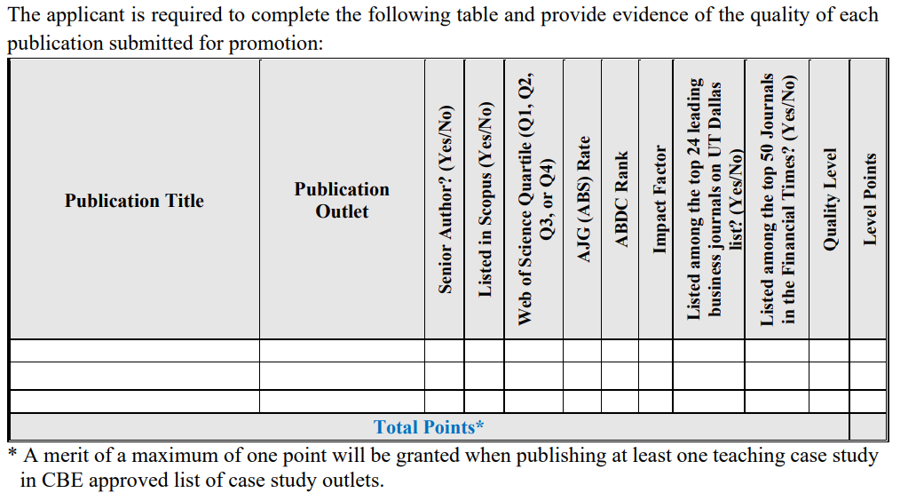

(***): Guidelines for iThenticate report for Promotion File:

1. Use the iThenticate software to check the similarity of the paper.
2. Exclude the similarity with the same article/abstract because these are already published and the software will show similarities with the same published article/abstract.
3. Exclude the working papers of the same article (WP series)
4. Excludeall the articles that cited the candidate’s paper and are published after the publication date of the paper.
5. Exclude the references

**** Guidelines for assessment

