 | 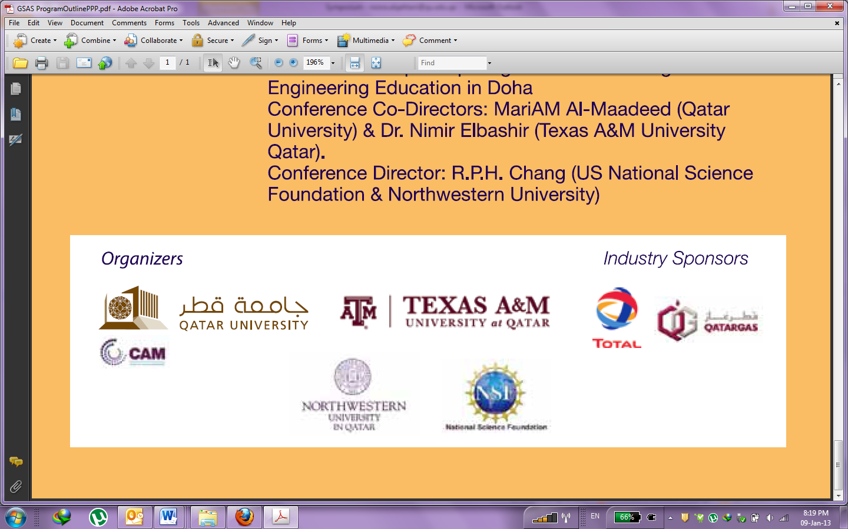

CONFIRMATION FOR THE MINOR’S SUPERVISION

Herewith I confirm in activities related to my minor student group in that
- Supervision in labs will be provided all the time;
- All activities will be conducted and adhered according to Health and safety manual and related SOP and Guidelines see https://www.qu.edu.qa/offices/FacilitiesGeneralServices/HSE/HS_Policy_and_Guidelines and Policy, guidelines and procedures for CAM lab use;
- MSDS for all chemicals will be provided and adhered to young students;
- Any activities on instrument will be done by authorized persons.

Name:
Signature:
Date:

